MICROECONOMICS PRODUCT ASSIGNMENT

BUTTON

A Microeconomic Analysis of Production, Cost, Demand, and Market Dynamics

Name: Astha Agrawal
Roll No: HBM25002
Class: MMS Batch 2025-27
Semester: 01st
Academic Year: 2025-2026
Institute: Sydenham Institute of Management Studies,
Research and Entrepreneurship Education, Mumbai
1. INTRODUCTION AND EVOLUTION
1.1 Definition of Button as an Economic Product
A button, in economic terms, represents a fundamental fastening mechanism employed in the garment and apparel industry, serving both functional and aesthetic purposes. From a microeconomic perspective, buttons constitute a derived demand product, meaning their demand is not autonomous but directly proportional to the demand for finished apparel. Despite their diminutive scale, typically ranging from 8 to 100 millimeters in diameter, buttons constitute a substantial market with complex production economics and intricate supply chain dynamics.
The global buttons market was valued at USD 2,126.29 million in 2024, projected to reach USD 2,923.21 million by 2033 (CAGR 3.6%). This correlates with apparel industry expansion, valued at USD 1.77 trillion in 2024 and anticipated to reach USD 2.26 trillion by 2030 (CAGR 4.2%). Global button production reached 5,000 million units in 2024, compared to 4,200 million in 2019, demonstrating consistent demand growth.
1.2 Historical Evolution of Buttons
The button industry reflects remarkable technological progression spanning over a century. India's Mehsi region established the world's first organized button manufacturing cluster in 1905, when Bhulawan Lal initiated handcrafted pearl button production using oyster shells. By World War II, Mehsi housed 160 factories employing 10,000 artisans, with output reaching 24 lakh gross annually. The introduction of synthetic plastic buttons in the 1950s-1960s disrupted this industry, demonstrating microeconomic principles of technological substitution and comparative advantage.
1.3 Types of Buttons
Contemporary button manufacturing encompasses diverse material categories, each serving specific market segments and price points:

Table 1.1: Classification of Buttons by Material Type
Button Type | Material Composition | Primary Application | Market Share
Polyester Buttons | Unsaturated polyester resin | Mass-market shirts, casual wear | ~50%
ABS Plastic | Acrylonitrile-Butadiene-Styrene | Premium garments, uniforms | ~20%
Metal Buttons | Brass, steel, zinc alloy | Denim, outerwear, formal wear | ~15%
Natural Shell | Mother-of-pearl, coconut shell | Luxury tailoring, ethnic wear | ~8%
Wooden Buttons | Hardwoods with resin composite | Eco-conscious brands | ~5%
Snap Buttons | Metal with fabric covering | Jackets, children's wear | ~2%

1.4 Classification: Evergreen Product
Buttons are classified as an Evergreen product within the product lifecycle framework. Unlike sunrise or sunset products, buttons demonstrate continuous structural demand from the need for garment fastening. Global apparel consumption grows at 3-4% annually, translating to stable button demand without cyclical volatility.
Despite advances in alternative fasteners like velcro and zippers, buttons remain irreplaceable for formal wear and traditional garments. Button demand has remained resilient during economic downturns, with only 2-3% volume contractions during recessions compared to 15-20% declines for discretionary fashion accessories.
1.5 Technological Evolution in Button Manufacturing
The technological trajectory of button manufacturing represents a fascinating case study in industrial economics. The transition from artisanal craft production to capital-intensive, technology-driven manufacturing has fundamentally transformed industry economics. Manual production in 1905 yielded 50-100 pieces per artisan daily, whereas modern automated injection molding facilities produce over 20,000 gross (2.88 million pieces) daily with minimal labor input.
Contemporary button manufacturing remains dominated by injection molding technology, with Italian firms Bonnetti and Giusi dominating global machinery supply. Advanced machinery incorporates IoT integration, real-time quality monitoring, and modular design allowing rapid mold changeover, which is critical for short-run customization demands in the premium segment. The button-making machines market valued at USD 150 million in 2024 is projected to reach USD 250 million by 2033, growing at 6.5% annually.
2. BACKEND ANALYSIS
2.1 Production Modality
Button manufacturing employs sophisticated production technologies that have evolved significantly over the past decades. Injection molding constitutes the predominant manufacturing methodology for plastic and polyester buttons, accounting for approximately 80-85% of global production. The process unfolds through four sequential stages:
- Clamping: The mold (typically steel for durability or aluminum for lower-volume production) is securely closed under hydraulic pressure.
- Injection: Melted plastic maintained at material-specific temperatures (ABS at 200-240°C, polypropylene at 160-180°C) is injected under high pressure into the mold cavity.
- Cooling: The plastic solidifies within the mold, with cycle times varying from 20-60 seconds depending on material properties and button geometry.
- Ejection: Finished buttons are extracted using ejection pins, typically requiring draft angles of 1-2 degrees to facilitate separation.
This manufacturing paradigm demonstrates substantial economies of scale. Multi-cavity molds enable simultaneous production of 4-16 buttons per cycle, dramatically reducing per-unit costs as output volume increases.
Table 2.1: Evolution of Button Manufacturing Technology
Era | Technology | Output Capacity | Labor Requirement
Pre-1950s | Hand-crafted (shell/bone) | 50-100 pieces/day | High (10+ workers)
1950s-1980s | Semi-automatic molding | 5,000 gross/day | Medium (5-8 workers)
1980s-2010s | Automatic injection molding | 15,000 gross/day | Low (3-5 workers)
2010s-Present | IoT-enabled automation | 20,000+ gross/day | Minimal (2-3 operators)

2.2 Raw Materials and Factor Market
The raw material landscape for button manufacturing reflects geographic cost advantages and material specialization. Polyester resin, derived from petroleum derivatives, remains the dominant input material accounting for approximately 50% of button production globally. India's strategic advantage in button manufacturing reflects low-cost polyester resin access through domestic petrochemical capacity from companies like Reliance Industries and GAIL.
Table 2.2: Raw Material Sources and Costs
Material | Source Region | Cost (Rs./kg) | Application
Polyester Resin | India, China, Middle East | 80-120 | Standard buttons
ABS Resin | Taiwan, South Korea, Germany | 150-200 | Premium buttons
Brass/Steel | India, Southeast Asia | 250-400 | Metal buttons
Mother-of-Pearl | Indonesia, Philippines | 800-1,500 | Luxury segment
Recycled PET | India, Europe | 60-90 | Eco-friendly buttons

The labor market exhibits low skill-intensity. Mold technicians command Rs. 25,000-50,000 monthly. Machine operators earn Rs. 12,000-18,000, quality inspectors Rs. 15,000-25,000, while logistics workers earn Rs. 8,000-12,000 monthly.
Injection molding machines range from Rs. 8-15 lakhs for semi-automatic to Rs. 25-40 lakhs for fully automatic systems. Mold fabrication costs Rs. 50,000-2,00,000 depending on complexity. Total project capitalization for a small unit is Rs. 16.03 million, with IRR of 42%.
2.3 Cost Structure Analysis
The cost structure of button manufacturing demonstrates classical microeconomic principles of fixed versus variable costs and economies of scale. For a typical 5,000 gross per-day button manufacturing facility, the capital expenditure breakdown is as follows:

Table 2.3: Capital Expenditure (CAPEX) Breakdown
Component | Cost (Rs. Lakhs) | Percentage
Injection molding machines (3-4 units) | 30-40 | 40-45%
Molds and tooling | 8-12 | 10-15%
Finishing and trimming machines | 5-8 | 7-10%
Quality control equipment | 2-3 | 3-5%
Infrastructure (building, utilities) | 12-15 | 15-18%
Working capital (3 months) | 8-10 | 10-12%
Total CAPEX | 65-88 | 100%

Table 2.4: Operating Expenditure (OPEX) Structure
Cost Category | Monthly (Rs. Lakhs) | Per Piece (Paisa) | Percentage
Raw material (polyester resin) | 2.5-3.2 | 1.67-2.13 | 40-45%
Labor (operators, QC) | 1.2-1.5 | 0.80-1.00 | 15-18%
Utilities (electricity, water) | 0.6-0.8 | 0.40-0.53 | 7-10%
Packaging materials | 0.5-0.7 | 0.33-0.47 | 6-8%
Maintenance and repairs | 0.3-0.4 | 0.20-0.27 | 4-5%
Administrative overheads | 0.4-0.6 | 0.27-0.40 | 5-7%
Total Monthly OPEX | 5.5-7.2 | 3.67-4.80 | 100%

The fixed costs comprising factory rent, insurance, administrative salaries, and depreciation amount to approximately Rs. 0.8-1.2 lakhs monthly, representing 15-18% of total OPEX. Variable costs including raw materials, direct labor, utilities, and packaging constitute Rs. 4.7-6.0 lakhs monthly, representing 82-85% of OPEX. This cost structure demonstrates button manufacturing's leverage to volume: at 50% capacity utilization, average cost reaches Rs. 5.5-6.5 per gross, but at 85% capacity, average cost declines to Rs. 3.8-4.2 per gross, reflecting strong economies of scale.
The following figure illustrates the behavior of Average Total Cost (ATC), Marginal Cost (MC), and Average Variable Cost (AVC) curves in button manufacturing:
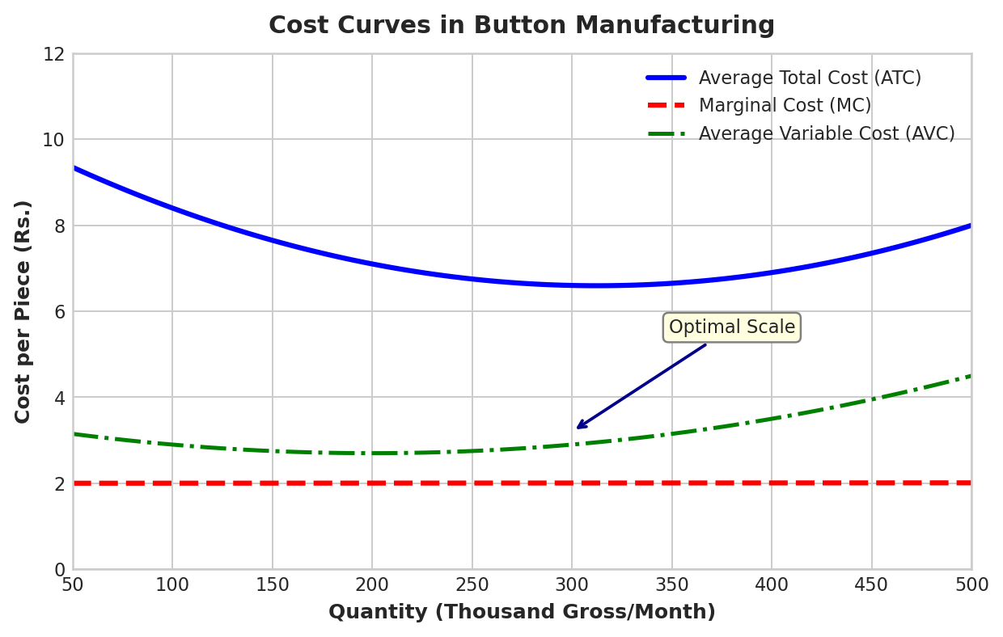
Figure 2.1: Cost Curves in Button Manufacturing
2.4 Supply Chain Analysis
The button supply chain exhibits a three-tier architecture. The backend comprises raw material suppliers, button manufacturers, and wholesalers. The frontend connects wholesalers to garment manufacturers, retailers, and end consumers.
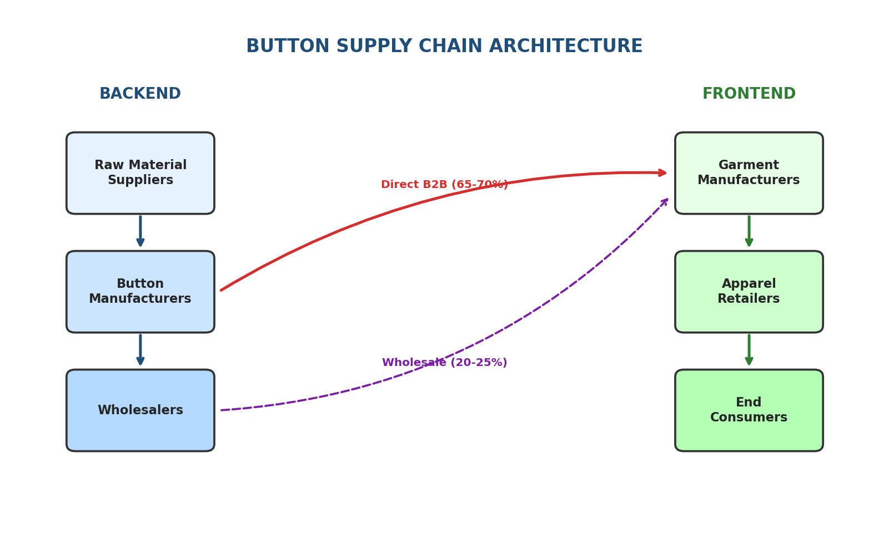
Figure 2.2: Button Supply Chain Architecture
In Mumbai, wholesale button markets are concentrated in areas such as Mulji Jetha Market in Kalbadevi, Crawford Market, and Mangaldas Market. These markets serve as critical aggregation points where garment manufacturers can source diverse button varieties from multiple suppliers. Typical wholesaler margins range from 8-12% between manufacturer wholesale price (Rs. 2.50-3.00 per piece) and retail price to garment makers (Rs. 2.75-3.50 per piece).
Large Indian button manufacturers exhibit partial backward integration. Bhansali Buttons, operating at 20,000 gross per day capacity, maintains in-house resin processing and quality labs, reducing input costs by 8-15% versus purchasing pre-processed materials.
2.5 Government Policies
The regulatory framework governing button manufacturing in India encompasses taxation, MSME support, and environmental compliance:
Goods and Services Tax (GST): Buttons (HS Code 9606) are subject to 18% GST. Manufacturers can claim Input Tax Credit (ITC) on inputs including resin, packaging, and utilities, enabling net tax neutrality on inter-state B2B sales. Small manufacturers with turnover below Rs. 1.5 crore can opt for the Composition Scheme at 1% fixed GST without ITC benefit.
MSME Support Schemes: The Credit-linked Capital Subsidy Scheme (CLCSS) provides subsidized interest on capital loans for manufacturing equipment. The Prime Minister's Employment Generation Programme (PMEGP) offers subsidies up to Rs. 25 lakhs for micro-enterprises.
Environmental Regulations: Under the Plastic Waste Management Rules (2016), Extended Producer Responsibility (EPR) Authorization is mandatory for plastic button manufacturers. Manufacturers must ensure recycling of 30% of plastic waste generated within 5 years.

3. FRONTEND ANALYSIS
3.1 Demand Analysis
Button demand exemplifies derived demand in industrial economics. The demand for buttons is not autonomous but flows directly from demand for finished apparel. The mathematical relationship can be expressed as:
Demand for Buttons = f(Demand for Apparel, Buttons per Garment, Substitution Rate)
The elasticity of button demand to apparel demand demonstrates near-unity elastic response: a 1% increase in apparel production yields approximately 0.95-1.05% increase in button demand. Global button production reached approximately 5,000 million units in 2024.
The key determinants of button demand include:
- Apparel Production Volume: The primary driver, with global apparel market CAGR of 3.5-4.2% translating directly to button demand growth.
- Garment Type Composition: Formal wear requires 4-6 buttons per garment, while casual t-shirts require 0-2 buttons, affecting aggregate demand.
- Consumer Preferences: Growing demand for personalized and eco-friendly buttons reflects changing consumer preferences.
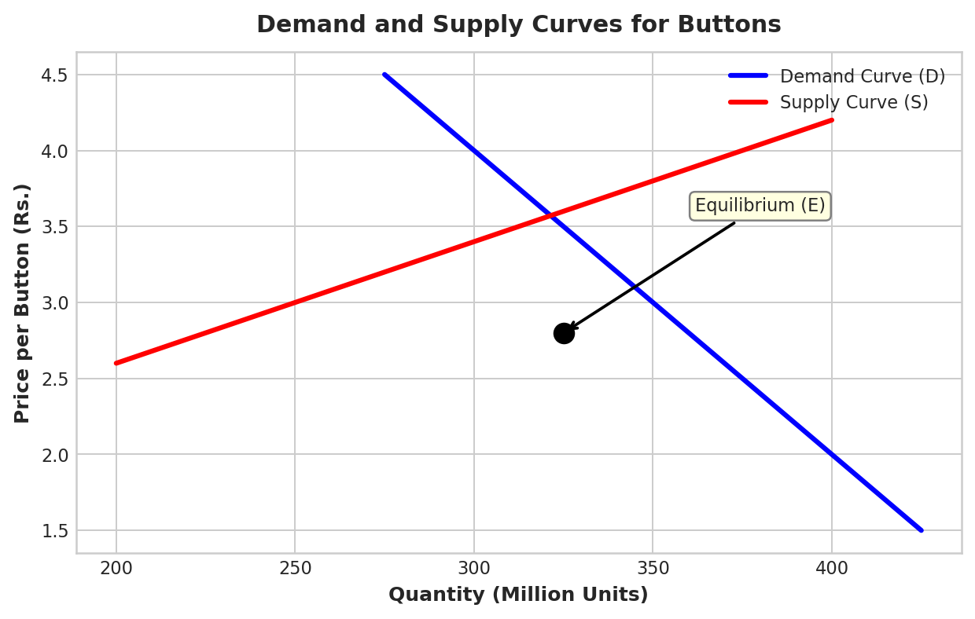
Figure 3.1: Demand and Supply Curves for Buttons
3.2 Elasticity of Demand
Price Elasticity of Demand (PED): Button demand exhibits inelastic pricing characteristics with an estimated PED of -0.3 to -0.6. This inelasticity is justified by several factors:
- Buttons represent less than 0.5% of total apparel manufacturing cost, making price insignificant to garment maker purchasing decisions.
- No close substitutes are available for basic functional buttons without requiring garment redesign and manufacturing process changes.
- Derived demand inherently exhibits lower price sensitivity than final consumer demand.
Table 3.1: Elasticity Measures for Button Demand
Elasticity Type | Estimated Value | Interpretation
Price Elasticity (PED) | -0.3 to -0.6 | Inelastic - small quantity change for price change
Income Elasticity (YED) | +0.9 to +1.1 | Unit elastic - grows with apparel consumption
Cross Elasticity (Velcro) | +0.45 to +0.65 | Substitute - moderate substitutability
Cross Elasticity (Zippers) | +0.10 to +0.20 | Weak substitute - different applications

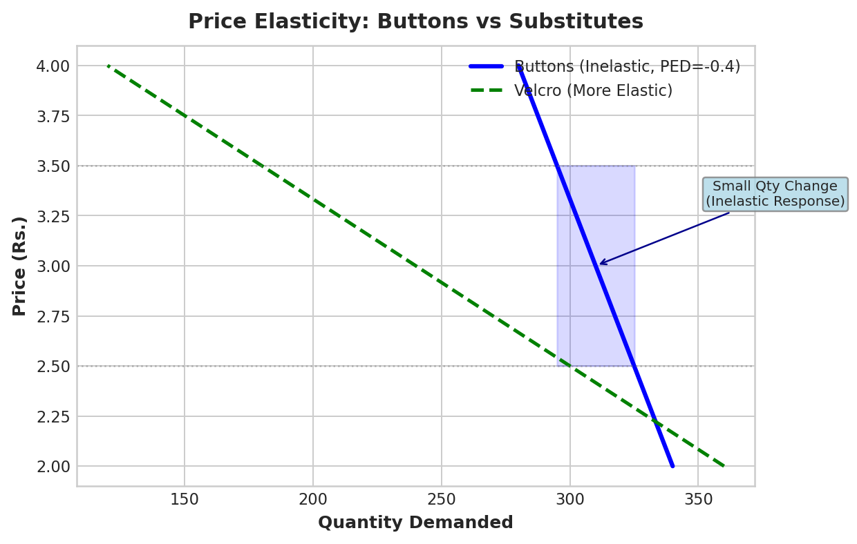
Figure 3.2: Price Elasticity - Buttons vs Substitutes
Income Elasticity of Demand (YED): Button demand exhibits unit-elastic income response (estimated YED of +0.9 to +1.1). Button demand grows proportionally with real apparel consumption. Economic downturns correlate with 2-3% button volume reductions.
Cross-Price Elasticity of Demand: Velcro demonstrates moderate substitutability with a cross-elasticity of +0.45 to +0.65. The relatively low overall cross-elasticity confirms button demand's structural stability.
3.3 Market Structure
The button market exemplifies monopolistic competition, characterized by the following features:
- Large number of competitors: India has 200+ registered manufacturers and 500+ unregistered MSME operations.
- Product differentiation: Variations in material, sizes (8-100 ligne), colors (50+ options), and special effects.
- Free entry and exit: Low capital requirements (Rs. 60-80 lakhs), minimal regulatory barriers, and mature technology.
- Non-price competition: Design innovation, sustainability certifications, quality assurance, and logistics efficiency.
Market concentration analysis reveals a fragmented industry structure. The top 5 manufacturers control approximately 12-15% of the Indian market, the next 20 control 20-25%, and the remaining 250+ manufacturers control 60-65%.
3.4 Pricing Mechanism
Button pricing operates through a tiered structure based on order volume, material type, and value-added features:

Table 3.2: Volume-Based Pricing Structure
Pricing Tier | Order Volume | Price/Piece (Rs.) | Discount
Minimum Order Quantity | 100-1,000 gross | 3.20-3.50 | Base price
Standard Wholesale | 1,000-5,000 gross | 2.80-3.20 | 8-12%
Bulk Wholesale | 5,000-20,000 gross | 2.40-2.80 | 15-20%
Large Contract | 20,000+ gross | 2.00-2.40 | 25-30%

Table 3.3: Channel-Based Pricing
Channel | Price (Rs./piece) | Margin Structure
Manufacturer to Wholesaler | 2.50-3.00 | Base cost + margin
Wholesaler to Garment Maker | 2.75-3.50 | 8-12% markup
Retail (DIY, replacement) | 15-50 | 400-1,500% markup
E-commerce (bulk) | 2.00-2.75 | Competitive to wholesale

3.5 Revenue Analysis
Revenue streams in button manufacturing are distributed across multiple channels. Bulk sales to garment manufacturers constitute 80-85% of total revenue. For example, a manufacturer producing 150,000 gross per month at Rs. 2.70 per piece generates Rs. 58.5 lakhs in monthly revenue.
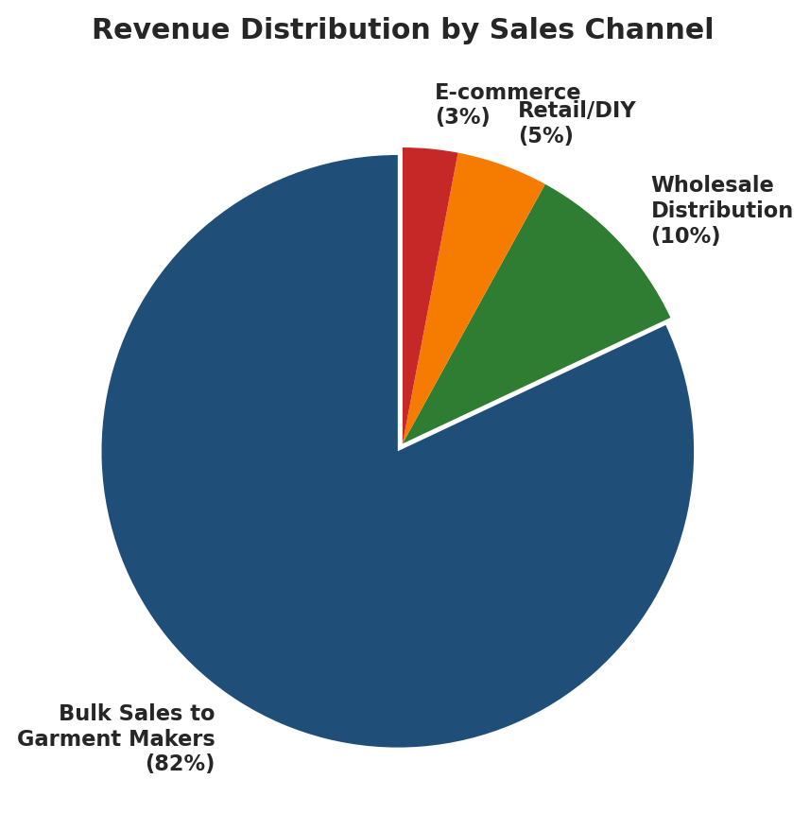
Figure 3.3: Revenue Distribution by Sales Channel
Total Revenue is primarily determined by volume given inelastic demand. Profit margins vary: manufacturers achieve 8-12% net margins, wholesalers 4-6%, while retailers capture highest margins on smaller volumes.
3.6 Selling and Marketing Costs
Button manufacturers invest minimally in B2C marketing (0.2-0.3% of revenue) due to the derived demand nature of the product. B2B marketing focuses on trade participation, catalog design, and quality certifications.
Table 3.4: Selling and Marketing Cost Structure
Cost Category | Rs./1000 pieces | % of Revenue
Packaging materials | 8-12 | 0.3-0.4%
Transportation/Logistics | 20-35 | 0.7-1.2%
Sales commissions (agents) | 15-25 | 0.5-0.8%
Marketing/Trade shows | 5-10 | 0.2-0.3%
Quality certifications | 10-15 | 0.3-0.5%
Total Selling Costs | 58-97 | 2.0-3.2%

4. SUGGESTIONS TO IMPROVE PRODUCTION AND DELIVERY EFFICIENCY
Based on the microeconomic analysis conducted, the following recommendations are proposed to enhance production efficiency, reduce costs, and improve supply chain effectiveness:
4.1 Cost Minimization Strategies
- Adopt multi-cavity mold technology: Transitioning from 8-cavity to 16-cavity molds can halve per-button production time and reduce average costs by 15-20%.
- Implement hot runner mold systems: These systems reduce material waste from 8-10% to 2-3%, with cost premiums amortized over 100 million+ pieces.
- Negotiate bulk procurement contracts: Large manufacturers achieve 15-20% discounts on polyester resin purchases versus MSMEs.
4.2 Supply Chain Efficiency Improvements
- Consolidate shipments using 40-foot containers: This reduces per-unit logistics cost by 25-30% versus Less Container Load (LCL) shipments.
- Establish regional distribution centers: Reducing delivery times to garment manufacturers improves service levels and reduces inventory costs.
- Implement Just-In-Time (JIT) inventory management: Coordinating production with demand reduces working capital requirements.
4.3 Sustainable Materials and Recycling
- Invest in recycled PET button production: Growing 8-12% annually, this segment commands only 10-20% cost premium while addressing ESG requirements.
- Develop bamboo button capacity: With only 5-10% cost premium and superior sustainability narrative, bamboo buttons serve eco-conscious brands.
- Implement Extended Producer Responsibility (EPR) compliance systems.
4.4 Technology Upgradation
- Deploy AI-enabled quality control: This reduces defect rates from 2-3% to 0.5-1%, improving customer satisfaction.
- Integrate IoT-enabled condition monitoring: Reduces unplanned downtime by 40% through predictive maintenance.
- Adopt energy-efficient cold-runner injection molding: Reduces energy consumption by 20-25% versus conventional heating methods.

CONCLUSION
The button industry exemplifies microeconomic principles where derived demand, economies of scale, and monopolistic competition converge. While buttons command Rs. 2-5 per piece, the aggregate market exceeding USD 2 billion reflects structural demand from a USD 1.7+ trillion apparel industry.
India's prominence as a cost-competitive global supplier while sustaining legacy production in Mehsi illustrates dynamic comparative advantage complemented by technology adoption. The sector's future depends on navigating sustainability imperatives while leveraging innovation.
The button industry's evolution from cottage industry through the polyester revolution demonstrates how microeconomic forces reshape industrial structure. This analysis shows how microeconomic theory applies to manufacturing contexts.

REFERENCES
[1] Market Reports World. (2024). Buttons for Clothing Market Size, Share & Trends Analysis Report.
[2] Grand View Research. (2024). Apparel Market Size, Share & Trends Analysis Report.
[3] East Champaran District Administration. (2024). Mehsi Button Industry - Historical Overview.
[4] Verified Market Reports. (2024). Automatic Button Making Machines Market Report.
[5] Apparel Resources. (2024). India's Bhansali Buttons: Innovation and Quality in Export Markets.
[6] Chetna International. (2024). Quality vs Cost: Buttons in Bulk Procurement.
[7] Market Research Future. (2024). India Apparel Market Size, Share & Industry Analysis.
[8] ClearTax. (2024). GST Rates for Buttons, Press Fasteners - HSN Code 9606.
[9] GST Lawyer. (2024). GST Provisions for the Textile Industry in India.
[10] Corpbiz. (2024). Environmental Compliance for Plastic Button Manufacturers.
[11] Cotton Monk. (2024). Sustainable Buttons: Eco-Friendly Fasteners Guide.
[12] OEC World. (2024). Global Button Trade Statistics and Analysis.
[13] IBEF. (2024). Indian Apparel Industry Analysis and Export Data.
[14] Scribd. (2020). Plastic Button Manufacturing Project Report.
[15] Gabe Clothing. (2024). Clothing Manufacturing Costs Breakdown.
[16] Investopedia. (2024). Derived Demand - Economic Concept Explanation.
[17] 6W Research. (2024). India Buttons for Clothing Market Outlook.

